1. How are inline and block elements different from each other?

Inline elements can exist within block level elements. Block level elements take up all of the available space within their parent container.

2. Explain the difference between visibility:hidden and display:none

Visibility :hidden , just makes the tag invisible. It will still be on the HTML page occupying space. It's just invisible.

Display: none , completely gets rids of the tag, as it had never exists in the HTML page

3. Explain the clear and float properties.

The clear property specifies what elements can float beside the cleared element and on which side.

The float property specifies how an element should float.

4. explain the difference between absolute, relative,fixed and static.

An element with position: absolute is positioned relative to the nearest positioned .

An element with position: relative is positioned relative to its normal position.

An element with position: fixed is position relative to the viewport, which means it stays at the same place even if the page is scrolled.

An element with position: static is positioned according to the flow of the page.

5. Write the HTML code to create a table in which there are 4 columns( ID , Employee Name, Designation, Department) and at least 6 rows. Also do some styling to it.

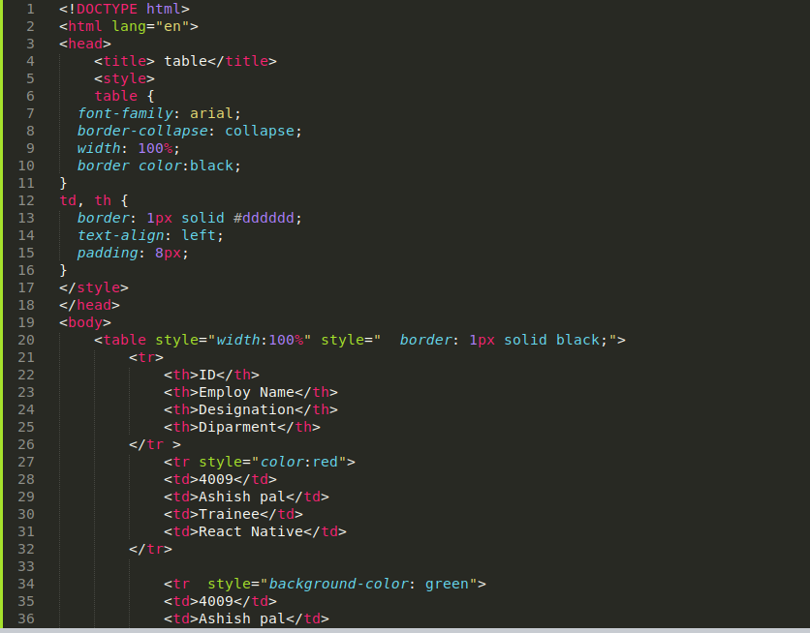

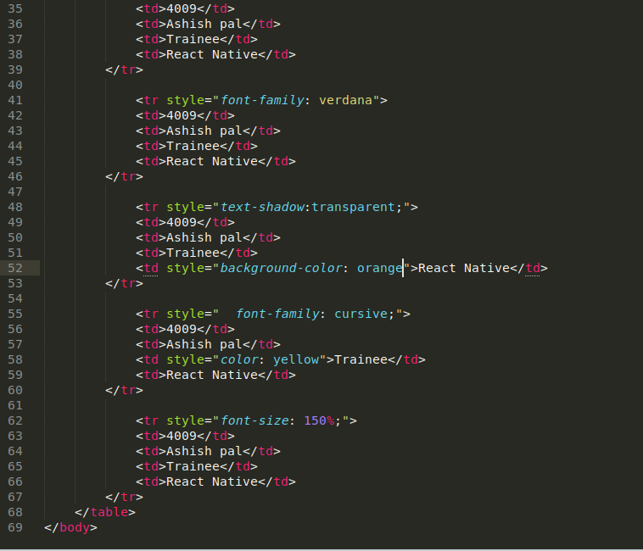

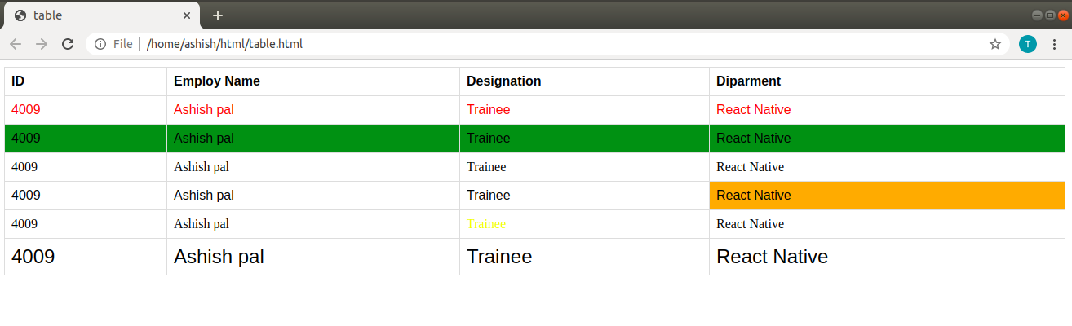

6. Why do we use meta tags?

The <meta> tag provides metadata about the HTML document. Meta elements are typically used to specify page description

7. Explain box model.

All HTML elements can be considered as boxes. In CSS, the term "box model" is used when talking about design and layout. The CSS box model is essentially a box that wraps around every HTML element. It consists of: margins, borders, padding, and the actual content

8. What are the different types of CSS Selectors?

Id selector

Element selector

Class selector

Group selector

Universal selector

9. Define Doctype.

The <!DOCTYPE> declaration must be the very first thing in your HTML document, before the <html> tag.The <!DOCTYPE> declaration is not an HTML tag; it is an instruction to the web browser about what version of HTML the page is written in.

10. write 5 HTML5 semantic tags.

Form

Table

Article

Header

footer

11. Create HTML for web-page.jpg (check resources, highest weightage for answers)

Answer- File attached in git folder

12. Create HTML for form.png (check resources, highest weightage for answers)

Answer- File attached in git folder